SPRINT-2

|  |  |
| --- | --- |
| **Team ID** | PNT2022TMID43975 |
| **Project Name** | IoT based smart crop protection for agriculture |

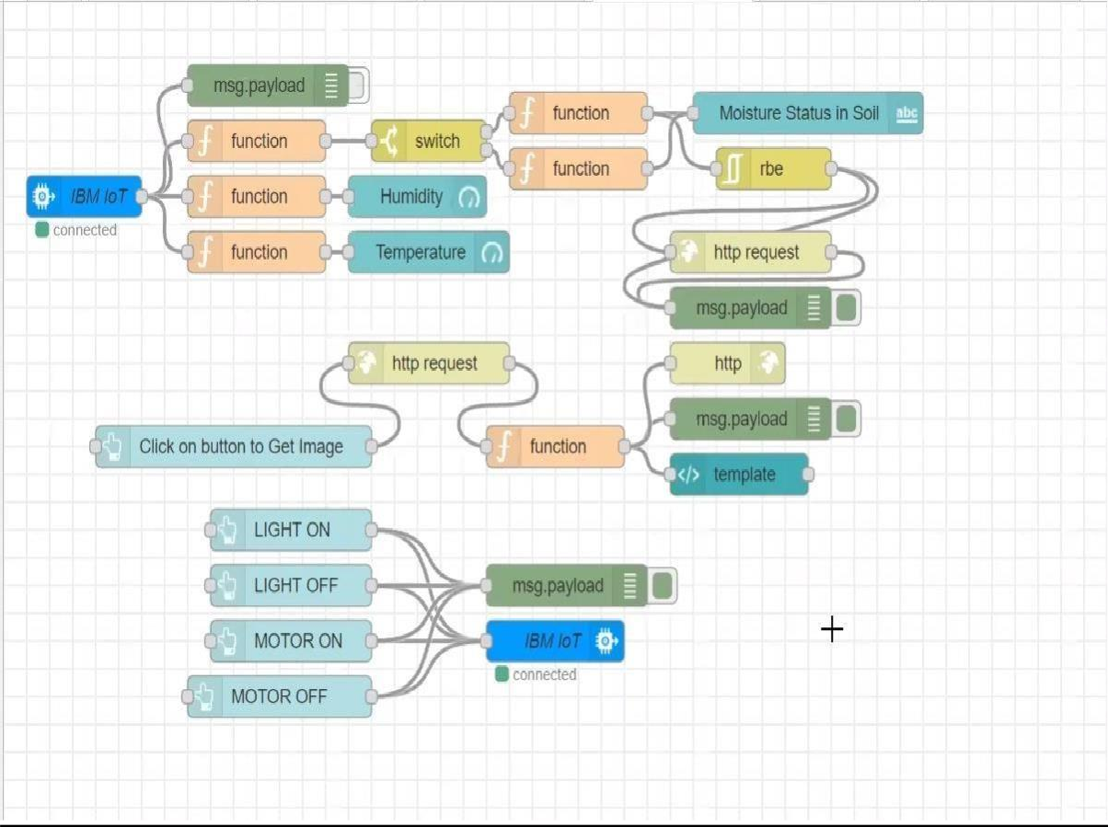

**OUTPUT 1:**

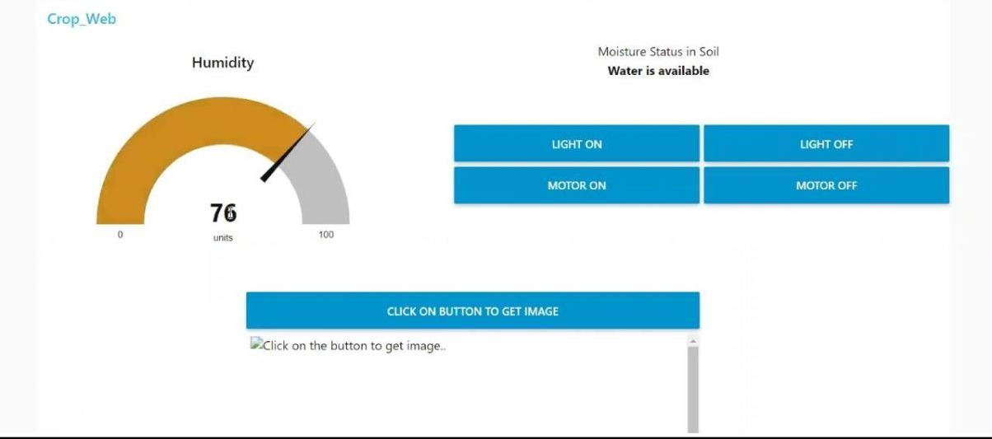

**OUTPUT 2:**

